Database Applications Lab – 01-09-2023

Create a relation CUSTOMERS with following attributes

create table customers(

ID int primary key,

cname varchar2(20),

age int,

Address varchar(20),

Salary number(10,3) default 1000.00

)



Create table supplier (

supplier_id numeric(10) not null,

supplier_name varchar2(50) not null,

contact_name varchar2(50),

CONSTRAINT supplier_pk PRIMARY KEY (supplier_id)

);

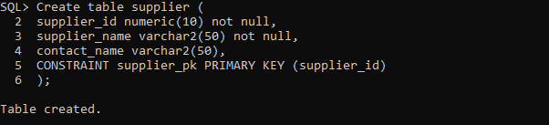

Composite Key

Create table supplier2 (

supplier_id numeric(10) not null,

supplier_name varchar2(50) not null,

contact_name varchar2(50),

CONSTRAINT supplier2_pk PRIMARY KEY (supplier_id,supplier_name)

);

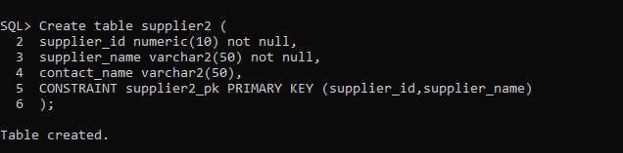

**Describe Relation**

DESCRIBE table_name;

DESC customers

DESCRIBE customers

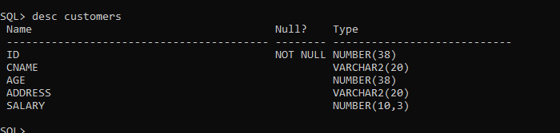

**Data Types**

Character Datatypes

* Char(size)
* VARCHAR
* VARCHAR2

Numeric Datatypes

* INTEGER
* FLOAT
* NUMBER(p,s) ex NUMERIC(10,3)
* DECIMAL
* BOOLEAN

Date/Time Datatypes

* DATE
* TIMESTAMP
* Large Object LOB
* BLOB

Create table student(

student_roll_no integer not null

, student_name varchar2(15) not null

, student_programme varchar2 (5)

, student_semester varchar2 (3)

, student_contact varchar2 (10)

, student_email varchar2 (20)

,CONSTRAINT student_pk PRIMARY KEY (student_roll_no , student_name)

);

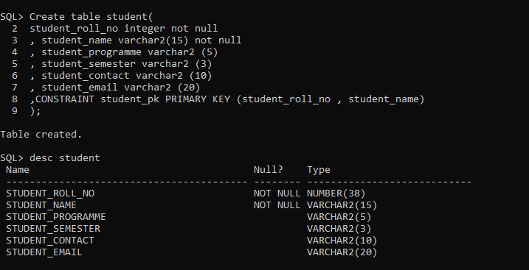

Q. Create EMPLOYEE table with following

ID(not null,number(5),primary key)

Empname(not null,varchar(20))

Address (varchar(30))

Age > 18 integer

Salary(Number (10,2))

Answer:

Create table employee(

eid number(5) not null

,ename varchar(15) not null

,address varchar(30)

,age number(2)

,salary number(10,2)

,CONSTRAINT age_check check (age > 18)

,CONSTRAINT employee_pk PRIMARY KEY(eid)

);

